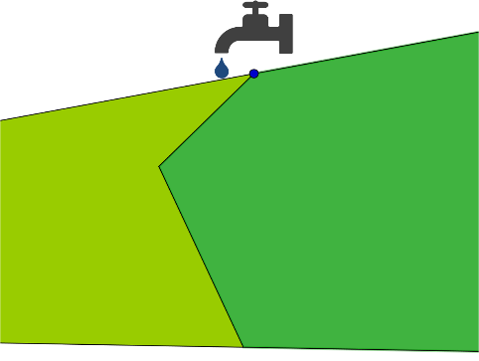
Two farmers each have a field with a shared boundary. On the boundary is a tap.
The farmers decide it would be more convenient if the boundary was a straight line, but they both need to access the tap.
Your challenge is to redraw the boundary so that:
- Both farmers can access the tap
- The boundary line is straight
- The new fields have the same areas as the original fields
Draw some pairs of fields with boundaries like the one shown above. Work out the areas of the fields, and then try to redraw the boundary so that it meets the farmers’ requirements.
Can you come up with a geometrical method for constructing the position of the new boundary?

Can you adapt your method to construct a boundary for a more complicated situation like the one pictured below?
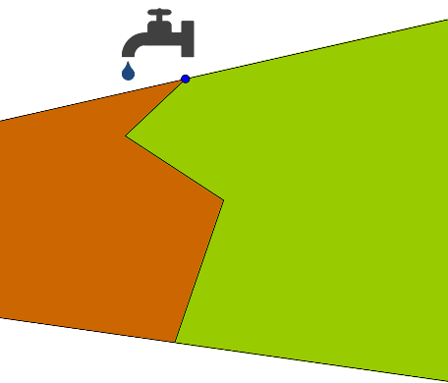

Can you describe a method for redrawing boundaries with four, five, or more straight lines into a single straight line?

